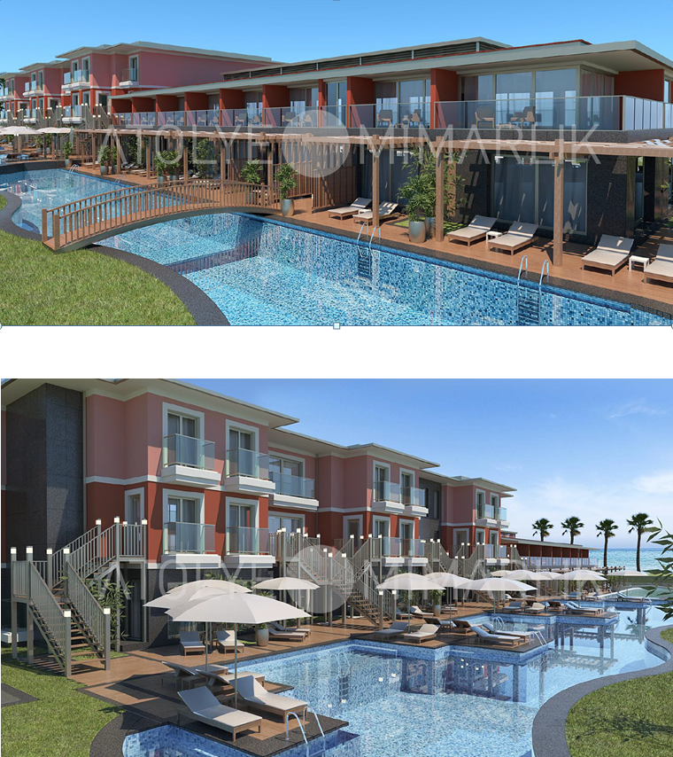

The plan of rooms in dublex style. There will be also plan of rooms with connection door.

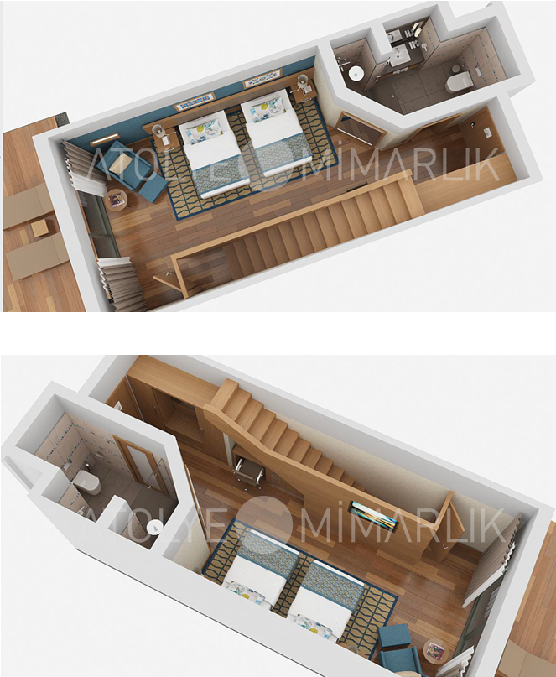

“DELUXE SWIM UP BEACH VILLA” LOCATION. 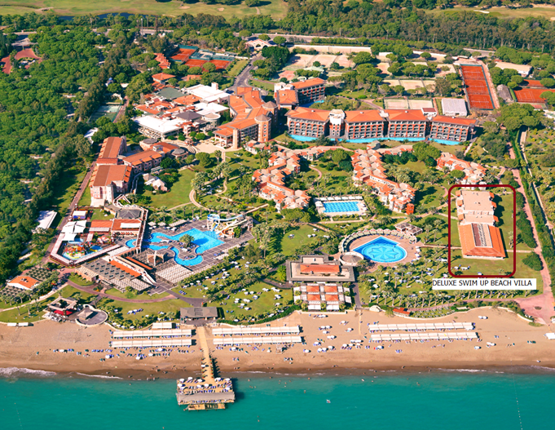

“Deluxe Swim Up Beach Villa” room type will be at your service from 01.05.2020 , in mentioned area on the map. This room type will be in connection style or dublex style. There are 2 WC and 2 dush/showers in this room type. There will be direct access to pool from ground

